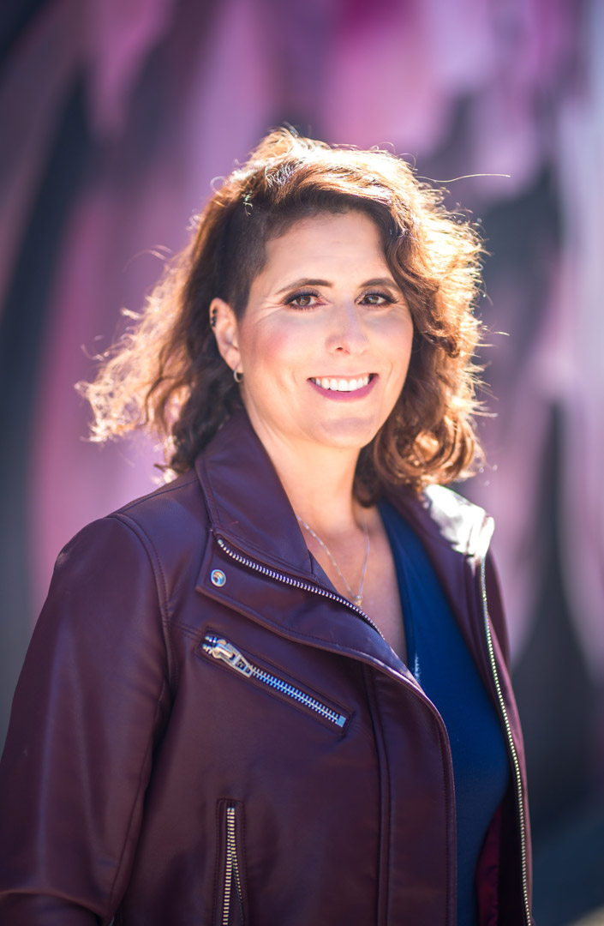

Dara Connolly Intro

I am excited to introduce you to our guest presenter! But first let me ask you a question…

If you could learn an easy way to MASTER public speaking and be more IMPACTFUL and INFLUENTIAL when speaking in front of an audience, would you be interested?

Well buckle up!

Our speaker “dares” you to speak on stage– even if you’re afraid!

As a recovered timid wallflower, she spent most of her life not speaking up- even though she is a black belt martial artist who can fly and crack wood.

Please help me welcome from the San Francisco Bay area, TEDx Speaker, author of 4 books including Flip Your Fear, avid traveler, and dog lover– the woman who dares you to speak with impact:

Dara Connolly!

